**AKSHITA JASORIA**

**Aim: Working of Hub and switch using Packet Tracer**.

**Outcome**

Learn about packet tracer

Learn the principles of networking and packet tracer

**Theory:**

**Hub**

A hub is to send out a message from one port to other ports. For example, if there are three computers of A, B, C, the message sent by a hub for computer A will also come to the other computers. But only computer A will respond and the response will also go out to every other port on the hub. Therefore, all the computers can receive the message and computers themselves need to decide whether to accept the message.

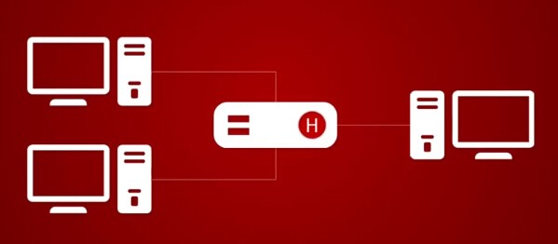

**Switch**

A switch is able to handle the data and knows the specific addresses to send the message. It can decide which computer is the message intended for and send the message directly to the right computer. The efficiency of switch has been greatly improved, thus providing a faster network speed.

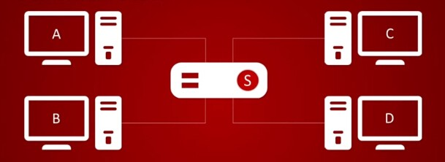

Create a scenario Using Hub and switch

Create star topology using hub

Create star topology using switch

Send the message using PDU between devices of respective topology

Simulate, compare and identify difference between both.

**Part B**

**STAR TOPOLOGY USING HUB**

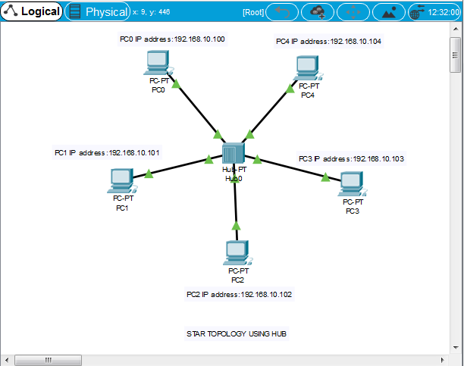

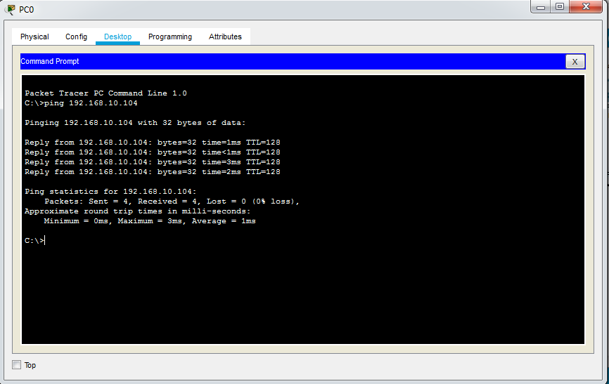

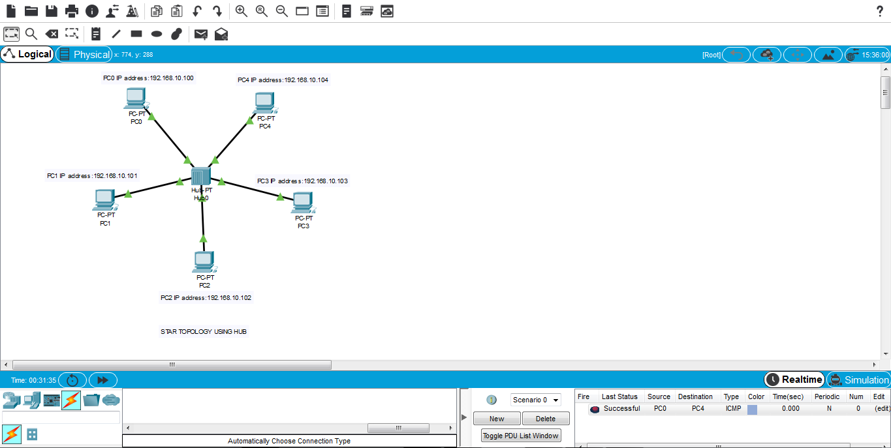

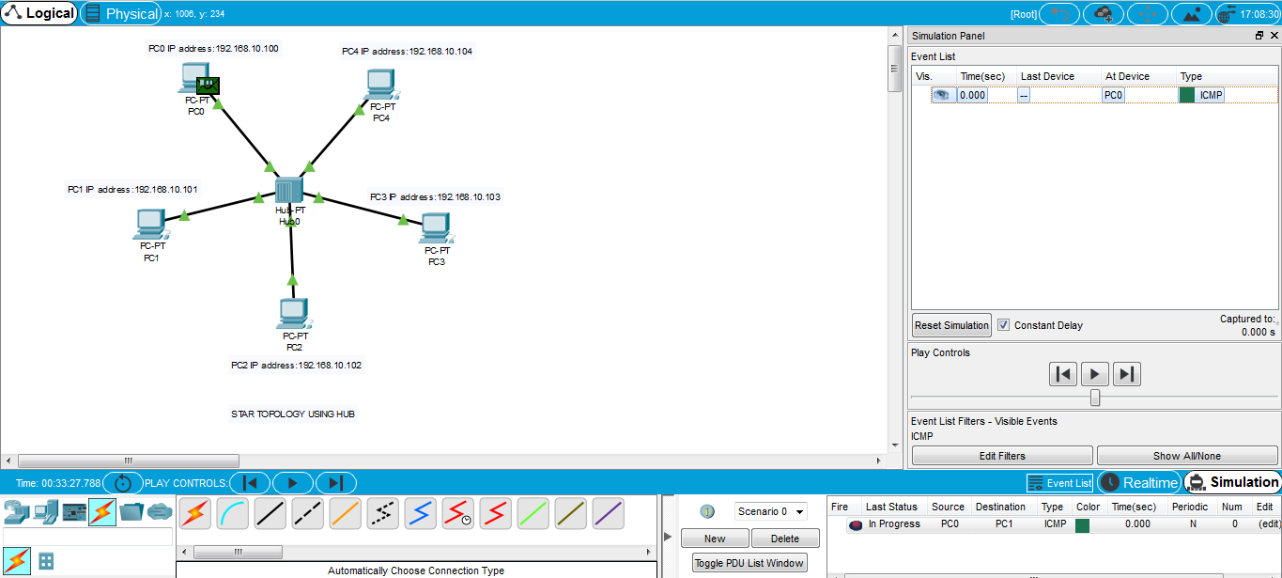

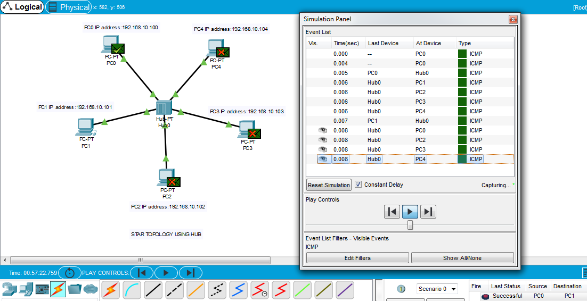

**STAR TOPOLOGY USING SWITCH**

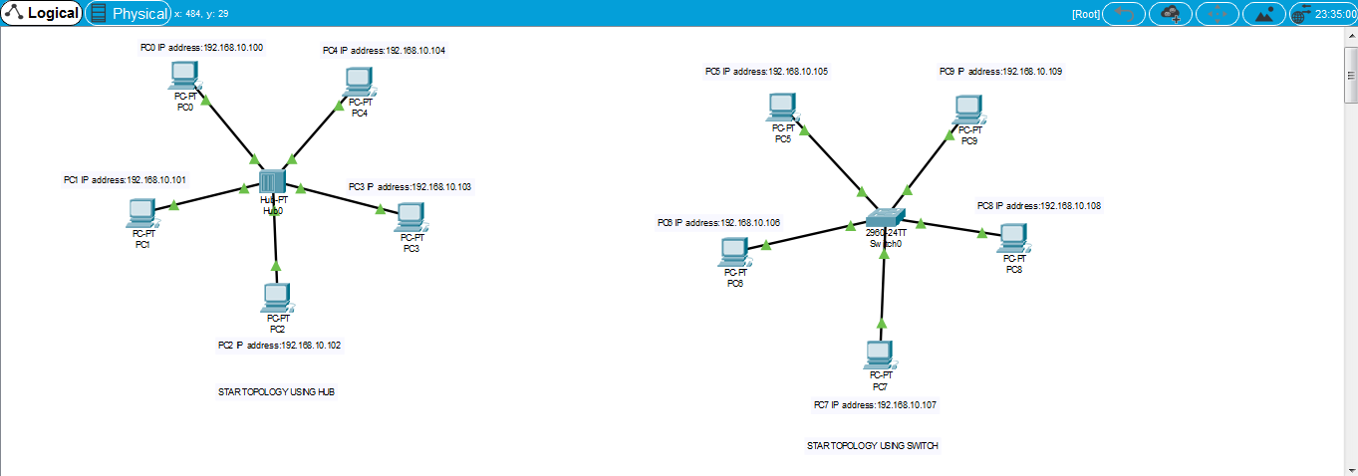

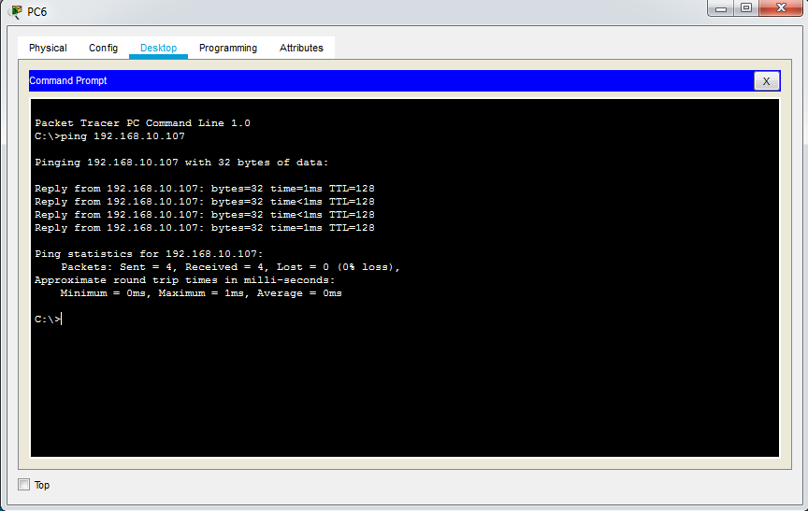

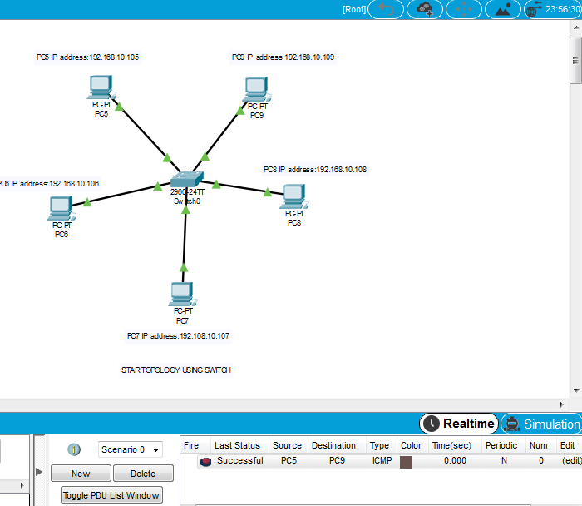

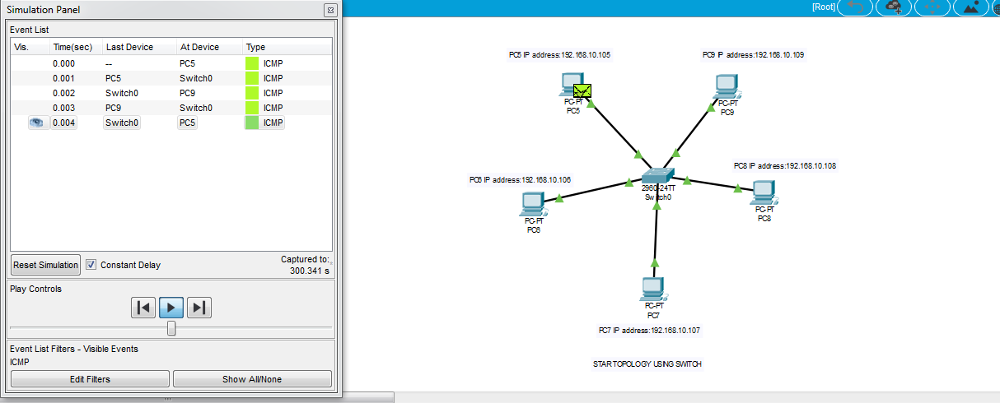

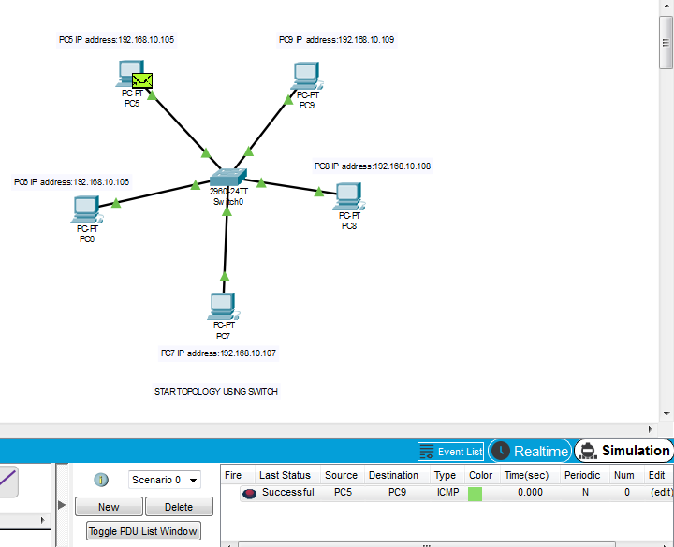

**Observation:**

A switch is used to connect various network segments. A network switch is a small hardware device that joins multiple computers together within one local area network (LAN). A Hub connects multiple Ethernet devices together, making them act as a single segment.

**Conclusion:**

Switches are intelligent than hubs.

**Question:**

In Hub and switch, which device is intelligent? Justify your answer.

**Answer:**

Switches operate on hardware addresses to transfer data across devices connected to them. The reason switches are known as intelligent hubs is because they build address table in hardware to keep track of different hardware addresses and the port to which each hardware address is associated.